A World After: Exploring the Changes
Brought on By COVID-19

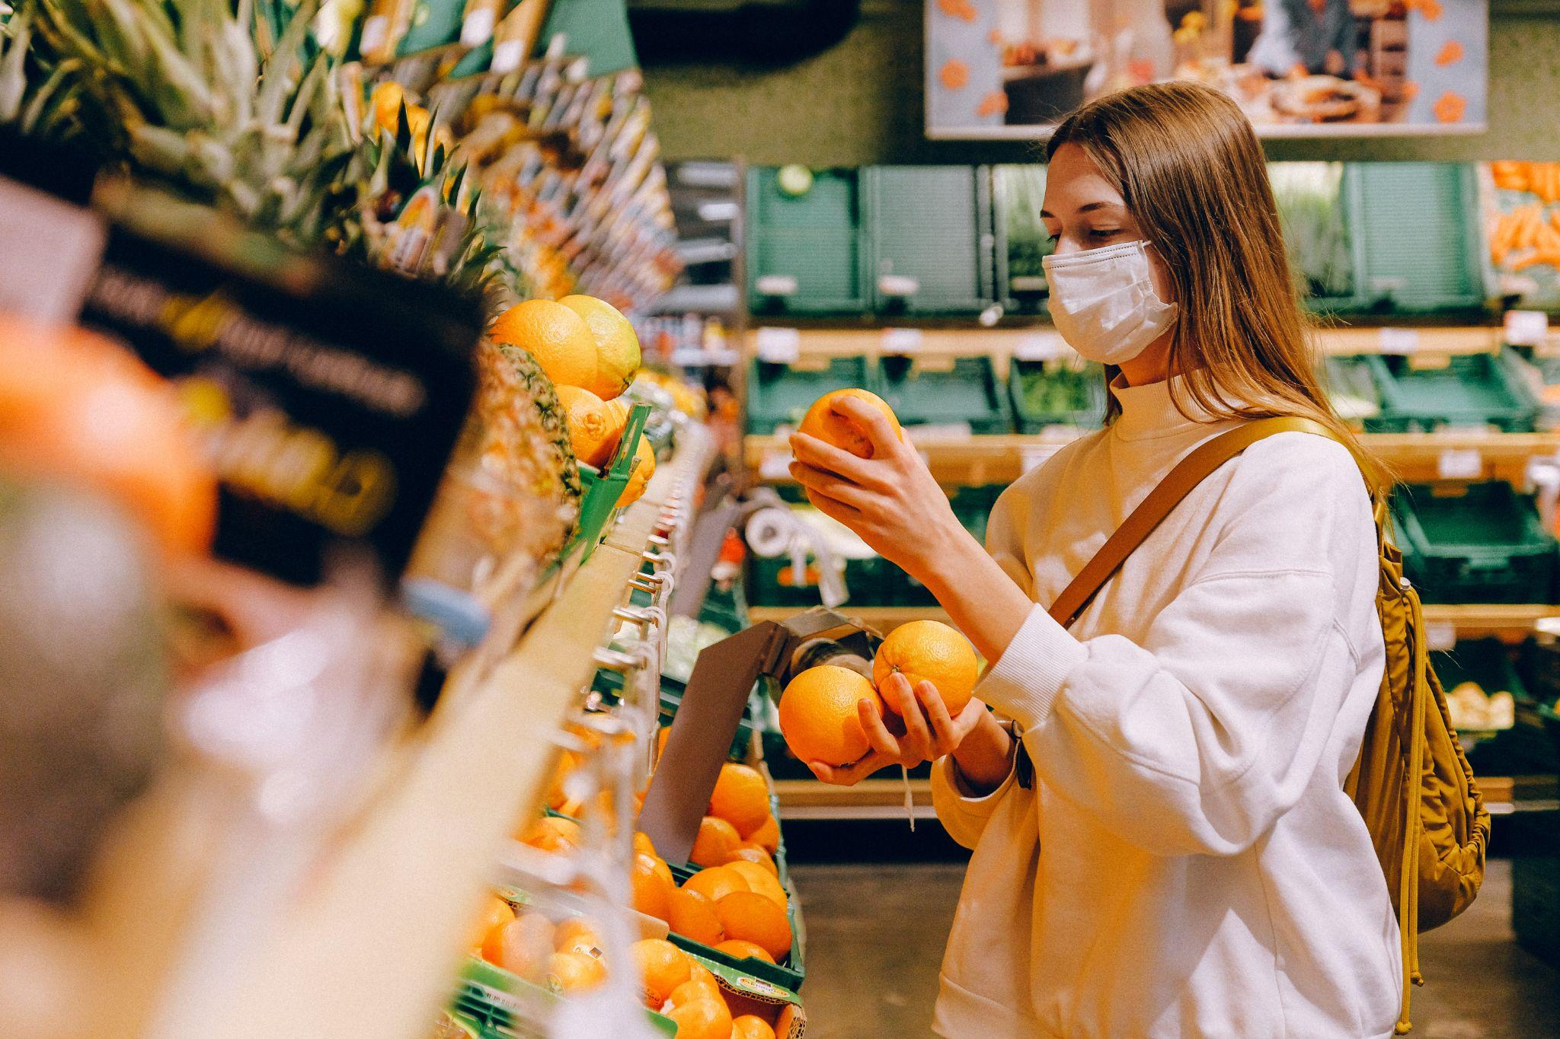

For many people, the pandemic has been a time of great upheaval, and while some changes have been blessings in disguise, others have proven difficult to manage. Here's a look at some of COVID-19’s impacts on employment, family dynamics, personal health, and more.

Employment

Perhaps one of the areas most severely impacted by the pandemic has been the job market. Strains on the economy have had a profound impact on America’s employment figures, with some employers forced to lay off staff and reduce hours. This is only now starting to inch back to normality. Some who have been in the same job for years have found themselves unemployed and scrambling to secure something new. Others may have been working multiple jobs to make ends meet and were forced to cut back to just one job or even stop working altogether, resulting in financial difficulty.

On the other hand, the pandemic has resulted in an acceleration of the digital economy and opened up new employment opportunities for many of us. With so many people working from home, there is a greater demand for childcare and home-based businesses. The startup economy has been kinder to entrepreneurs as remote working provides a great way to earn extra income and have more control over work schedules.

Family Responsibilities

Because the pandemic has changed the way people work, many families have had to adapt their homes to accommodate everyone being home all day. This can be both a good and a bad thing. On the one hand, it's great to have more flexibility with your work schedule. You can take breaks when you need to and don't have to worry about commuting.

However, working from home also invites distractions and loneliness. Kids add an extra level of difficulty to this challenge, as they are often unable to understand why you can’t be available to them during the working day. Some parents have found that they can't work as much as they used to because they're needed at home more. Others have had to get creative with their childcare arrangements. Nannies, daycare, and family members have seen increased demand to ease this burden.

Health and Fitness

The pandemic has made people a lot more conscious of their physical health, but with gyms and other fitness facilities closed, people have had to get creative with their workouts. Some have started working out at home, while others have taken up running or biking. Virtual fitness classes have seen increased use during this period.

There has also been a greater focus on mental health during the pandemic. With so much stress and uncertainty, and many people coping with loss, there has been an increase in the use of mental health services. Some people have started therapy, while others have joined support groups.

The pandemic has also changed the way people approach their diet. Many restaurants have closed, forcing people to spend more time cooking at home. This has led to an increase in the sale of groceries and home cooking, and homesteading.

Living Situations

Many of us have had to adjust our living situations during the pandemic, with some people moving in with family members or friends to save money or because they were lonely. We’ve also seen huge fluctuations in the housing market with prices rising and emphasis placed on rural properties - advances in tech also made it possible to check home design trends and prices without needing to conduct viewings in person.

The pandemic has led to significant changes in the way people live their lives, and while some of these changes have been difficult, others have been advantageous. As we move toward the future, it’s important to stay mindful of all that was lost and all that was gained during this period.

Life’s Journey explores the many roads traveled by people from all walks of life. We use experiences to gain wisdom, transformation, and a better understanding of the world around us. Find out more at: www.lifesjourney.us

Image by Pexels

